Appendix A - DEMOGRAPHIC INFORMATION AND SCHOOL ROLL PROJECTIONS 2023-2024 to 2035-2036 REPORT

Contents
- Introduction p 2
  - Harrow’s Context p 2
  - Harrow’s Vision for Education p 2-3
  - Harrow’s School’s Effectiveness p 3
  - Harrow’s School Place Planning Strategy p 3-4
  - Organisational Change p 4
- Harrow Council’s role in School Place Planning p 4-5
2.1 Demand for School Places p 5
2.2 Primary Places Demand p 6-10
2.2.1 Change in Demand for Primary School Places p 10
2.3 Secondary Places Demand p 10
2.4 Specialist Provision p 11-12
2.5 Harrow’s need for a new Special School p 12
2.6 Early Years – Childcare and Education p 12-13
2.7 Post-16 Provision p 13
- Harrow School Projections p 13-14
3.1 Numbers on Roll in Primary Schools p 14-15
3.2 Projections for Reception to Year 6 Primary School Pupils p 15-16
3.3 Projections for Reception Pupils p 17-18
3.4 Primary Schools Projections by Planning Area p 19-35
3.5 Numbers on Roll in Secondary Schools p 36
3.6 Projections for Year 7 to Year 11 Secondary School Pupils p 36-38
3.7 Projections for Year 7 Secondary School Pupils p 38-40
- Demand for Special Education Need Specialist Provision p 41
4.1 EHCPs maintained by Harrow p 41-42
4.2 SEND Projections and modelling SEND places within Harrow Council p 42-43

Annexes
Annexe 1: Child Population Projections 2023 p
Annexe 2: Overview of Harrow’s population and changes 2023 p
Annexe 3: GLA SRP Methodology 2023 p
Annexe 4: SEND and Early Years Data 2023 p

- INTRODUCTION

Harrow’s Children and Young People (CYP) are at the heart of Harrow’s community, and Harrow Council is responsible for their education, healthcare, and wellbeing. Harrow Council has the statutory duty to ensure that they provide sufficient school places for its children, an integral part of this duty is to ensure the best outcomes for Harrow’s children. This report sets out the decisions that the council makes to achieve this duty.

  - Harrow’s context

Approximately 82,100 CYP aged 0 to 25 years live in Harrow. This is 31% of the total population (261,300) in the area. (Source: 2021 National Census). Harrow is one of the most culturally diverse boroughs in London, with residents from a variety of ethnic backgrounds, and speaking a range of languages. As at January 2023 92.0% of Harrow’s school population is classified as belonging to an ethnic group other than White British. The three main ethnic groups in Harrow’s schools are Indian (26%), Asian Other (18%) and White Other (17%). Over 150 languages are spoken by Harrow’s schools’ children, the top five most recorded languages spoken are English, Romanian, Gujarati, Arabic and Tamil.

The 2019 Income Deprivation Affecting Children Index (IDACI) shows that 12.3% (16.2% in 2015) of children in Harrow are living with families that are income deprived, this equates to approximately 6,500 children. Deprivation is most prevalent in the centre and south-west of the borough – Wealdstone is Harrow’s most deprived ward, followed by the Marlborough and Roxbourne wards. In 2019 none of Harrow’s Lower Super Output Areas (LSOAs) are in the most deprived 10% in England, compared with three in 2015. The proportion of pupils in Harrow’s schools’ that were eligible for Free School Meals as at January 2023 was 17.6%.

  - Harrow’s Vision for Education

All children and young people should achieve the best possible outcomes, to enable them to become successful adults. They should have access to a continuum of good and outstanding educational provision that offers choice, progression and pathways and are supported by high quality, integrated and inclusive services from 0-25.
The Place Planning Strategy contributes to the Council’s vision statement for future education ‘High Achieving Schools at the Heart of Community Services’. Harrow’s schools are successful in comparison to our statistical neighbours. But the gap is closing, and schools need to continue in their improvement. As a Council we are committed to all schools being judged as either good or outstanding by Ofsted. Proposals for making changes to school organisation will ensure that school performance is given a high priority.
Harrow’s schools are at the heart of the community, they offer a range of opportunities to the local residents, and we need to ensure that the accommodation is managed and invested in, to realise this aspiration. School accommodation and sites need to support pupils’ learning but also to provide locations for activities and services. In considering school organisation we will work with schools and partners to ensure that where opportunities arise, services are co-located and facilities are developed for the school and local community.
  - Harrow’s School’s Effectiveness

Harrow is a popular borough for families due to the excellent reputation of its schools. Harrow’s School Standards and Effectiveness (HSSE) Team delivers statutory and core school improvement support to Harrow schools. HSSE work closely with schools to maintain the educational achievements of children and young people in Harrow, as well as the effectiveness of the quality of education in our early years’ settings, schools and colleges.

HSSE’s shared vision for school improvement is:
- Ambitious – an educational offer which is inclusive, stimulating and aspirational; it inspires a lifelong love of learning. It delivers positive outcomes in achievement, skills, progress and ambition for every child and young person
- Inclusive – children and young people feel safe, valued and happy; they are resilient and empowered to overcome disadvantage and fulfil their potential. Families feel valued, supported and engaged in their children’s education
- Collaborative – a system that is collaborative and self-improving, with all partners sharing a collective responsibility for all learners.

Outcomes for children and young people in Harrow are above the national average at EYFS, KS2 and KS4, as is the proportion of good and outstanding early years settings and schools. Schools in Harrow perform well in comparison to national and statistically similar local authorities. The vast majority of primary schools and secondary schools are judged ‘good’ or ‘outstanding’ by Ofsted. As at 13th November 2023, 96% of Harrow’s primary and secondary schools are judged ‘good’ (51.4%) or ‘outstanding’ (44.6%), which is above both, 95.3% in Outer London (68.5% Good, 26.8% Outstanding) and 88.4% nationally (71.2% Good, 17.2% Outstanding) (Source: Watchsted Tables (ncer.org).

  - Harrow’s School Place Planning Strategy

The School Place Planning Strategy contributes to Harrow fulfilling its school organisation statutory responsibility in the Education and Inspections Act 2006 to secure sufficient school places within its area in order to promote higher standards of attainment.
The strategy:

- states the vision for achieving higher education standards in Harrow.
- outlines the action that the Local Authority (LA) will be undertaking for the next year.
- details the Borough’s current arrangements for the provision of places in statutory and non-statutory education, for pupils aged 0-25.
- sets the national and local context for school place planning.
- provides demographic and contextual information to support the development of proposals to change the number of school places.
- establishes a framework to develop proposals to manage school places.

  - Organisational change

In recent years the organisation of schools in Harrow has seen significant change:
- There are enhanced early years opportunities provided through the Children’s Centre programme, with a total of 16 centres in Harrow.
- As part of the Harrow Collegiate all community high schools, and voluntary aided schools have sixth form provision on their school sites, providing a range of curriculum pathways.
- All but 1 of Harrow’s separate first and middle schools have been amalgamated to establish combined primary schools.
- From September 2010, all schools in Harrow were aligned to be in line with the National Curriculum Key Stages and the ages of transfer changed.
- The local authority as commissioner of school places over the last 12 years has monitored and developed proposals to increase primary sector provision in line with projected and actual growth.
- There has been an increase in the provision for pupils with special educational needs including the bases for pupils with Autistic Spectrum Disorder (ASD) and Social, Emotional and Behavioural Difficulties.

  - Harrow Council’s role in School Place Planning

The Local Authority has the statutory duty for Pupil Place Planning – ensuring that there are sufficient school places for all pupils in the borough’s mainstream schools and settings for pupils with high needs (special schools and alternative provision, or AP).

The Local Authority works in partnership with the education settings within the borough, as well as outside the borough with regards to children with an EHCP, in order to ensure that there are sufficient places. Sufficient places are planned for through the management of places in Harrow’s schools, and when additional places are required bulge (temporary) classes are initially created and if the demand is sustained the classes can be made permanent. Alternatively, when the demand for places reduces the Local Authority works with its schools to manage the surplus places, one way of doing this is to reduce the Published Admission Number (PAN) of places, this is initially done on an informal basis and can be made permanent the following year. School closures are also an option to manage school places, however this not an option that Harrow has had to consider.
The LA has the overarching responsibility for school admissions, co-ordinating admissions at Reception, Year 3 (from infant to junior school) and secondary transfer to Year 7. Residents must apply to their home authority for a maintained school place, whether the school place is within the authority or out of borough. During the Admissions process, applications for a Harrow school from out borough residents are also considered and vice versa. The Local Authority in Harrow also co-ordinates the majority of in-year applications for schools in Harrow. If any Harrow resident is identified as being out of school, the school admissions team will ensure a place is offered within a reasonable distance from their home address.

The LA also has overarching responsibility for the assessment of children and young people (up to the age of 25) requiring an Education, Health, Care Plan, which includes the allocation of specialist provision in a setting that meets the needs of the CYP.

  - Demand for school places

School place planning focuses on four main areas

- Primary – Reception and Year 3
- Secondary – Year 7
- In-year – from Reception to Year11
- Specialist provision

Reception and Year 7 school place planning is done on both a borough-wide and a planning area basis. Harrow has five primary planning areas (PPA) and three secondary planning areas (SPA).

Harrow recently reviewed its planning areas in line with DfE guidance and an analysis of where pupils went to school in May 2021, based on pupils’ postcodes, has been used to determine the new planning areas. The new primary planning areas were redefined using Harrow’s new May 2022 wards. The DfE’s latest planning area guidance strongly recommended not using non-geographical planning areas, therefore a decision to include the voluntary aided primary schools in the existing 5 geographical planning areas was implemented. This resulted in the deletion of the Voluntary Aided primary planning area and Harrow therefore has 5 geographical primary planning areas. A map of Harrow’s primary planning areas is included on page 15 of this report.
Demand for school places in Harrow, alongside the rest of London rose significantly over the past decade, it rose at a faster rate than in any other region of the country. Harrow experienced a high demand for primary school places for a number of years, and then the demand transferred to secondary level as pupils reached secondary school age. To manage this increase, Harrow worked hard to put plans in place to ensure that the shortfall was met by increasing capacity in existing schools (primary school expansion programme), and by creating new school provision by working with free schools in both the primary and secondary sectors.

  - Primary Places Demand

The demand for primary places (Reception to Year 6) has overall continued to increase over the last two decades, increasing from 16,633 in 2005/06 to 21,561 in 2022/23. The demand for Reception places continued to increase from 2,224 in 2005/06 and reached a peak of 3,251 in 2014/15. This increase was managed through the opening of temporary classes, a 3-phased primary school expansion programme and the opening of new free schools.

Table 1a - Reception Bulge classes since September 2009
Planning Area | Bulge classes | 2009/10 | 2010/11 | 2011/12 | 2012/13 | 2013/14 | 2014/15
North East Planning Area (PA1) | Aylward |  |  |  |  | 1
 | Stanburn |  |  | 1 | 1
 | Weald Rise |  | 1 | 1
 | Whitchurch |  |  |  |  |  | 1
North West Planning Area (PA2) | Cannon Lane |  |  |  | 1 |  | 1
 | Cedars | 1 |  | 1 | 1
 | Grimsdyke |  |  |  |  |  | 1
 | Longfield |  | 1 |  |  | 1
 | Pinner Wood |  | 1 |  |  | 1
South East Planning Area (PA3) | Camrose |  |  |  | 1
 | Glebe |  |  | 1 | 1
 | Kenmore Park |  | 1 | 1 |  |  | 1
 | Priestmead |  |  |  |  |  | 1
 | Stag Lane |  |  |  |  |  | 1
South West Planning Area (PA4) | Grange | 1 |  | 1 |  | 1
 | Newton Farm |  |  |  |  |  | 1
 | Roxeth |  |  |  |  | 1
 | Vaughan |  |  |  | 1
 | Welldon Park | 1 |  |  | 1

Table 1b - Reception Bulge classes since September 2009
Planning Area | Bulge classes | 2009/10 | 2010/11 | 2011/12 | 2012/13 | 2013/14 | 2014/15
Central Planning Area (PA5) | Belmont | 1 |  |  |  | 1
 | Elmgrove |  |  |  | 1 |  | 1
 | Marlborough |  |  |  | 1
 | Norbury |  | 1 | 1 |  | 1
 | Pinner Park |  |  | 1 | 1
 | Whitefriars |  |  |  |  |  | 1
Faith Schools (PA6) | St Georges | 1
 | Avanti House |  |  |  | 2 | 2
 | St John Fisher |  |  |  |  |  | 1
Total ‘Bulges’ |  | 5 | 5 | 8 | 12 | 9 | 10
Total Places |  | 150 | 150 | 240 | 360 | 270 | 300

Table 2a - Reception Permanent classes since September 2013
Planning Areas | Permanent classes | 2013/14 Phase 1 | 2014/15 Phase 2 | 2015/16 Phase 3 | 2016/17 Phase 3
North East Planning Area (PA1) | Aylward |  | 1
 | Stanburn | 1
 | Weald Rise |  |  |  | 1
 | Whitchurch |  |  | 1
North West Planning Area (PA2) | Cannon Lane |  |  | 1
 | Cedars | 1
 | Grimsdyke |  |  | 1
 | Longfield |  |  | 1
 | Pinner Wood |  | 1

Table 2b - Reception Permanent classes since September 2013
Planning Areas | Permanent classes | 2013/14 Phase 1 | 2014/15 Phase 2 | 2015/16 Phase 3 | 2016/17 Phase 3
South East Planning Area (PA3) | Camrose | 1
 | Glebe | 1
 | Kenmore Park |  |  | 1
 | Priestmead |  |  | 1
 | Stag Lane |  |  |  | 1
South West Planning Area (PA4) | Grange |  | 1
 | Newton Farm |  |  | 1
 | Vaughan | 1
 | Welldon Park |  |  | 1
Central Planning Area (PA5) | Belmont |  | 1
 | Elmgrove |  |  | 1
 | Marlborough | 1
 | Norbury |  | 1
 | Pinner Park | 1
 | Whitefriars |  |  | 1
Faith Schools (PA6) | Avanti House |  | 2
 | Krishna Avanti | 1
 | St John Fisher |  |  | 1
 | St Jérôme |  |  |  | 2
Total Classes |  | 8 | 7 | 11 | 4
Total Places |  | 240 | 210 | 330 | 120

School Expansion Programme Phase 1
The number of Harrow’s Reception permanent places increased by 240 places to 2,790 in September 2013 following implementation of Phase 1 of the Primary School Expansion Programme. 7 community schools were expanded permanently along with the expansion by one form of entry of Krishna Avanti Primary School to become a 2 form of entry academy school. 9 temporary Reception classes brought total places in 2013/14 to 3,060.

School Expansion Programme Phase 2
In September 2014, Harrow’s Reception permanent places were increased by 210 places to 3,000 following the implementation of the first stage of Phase 2 of the Primary School Expansion Programme (this included two forms of entry at Avanti House free school). In order to meet the full increased demand for Reception places, 10 bulge classes (300 places) were opened at schools. In September 2015, Harrow’s Reception permanent places were increased by 330 permanent places in 11 schools following the full implementation of Phase 2 and the first permanent expansions in Phase 3.

School Expansion Programme Phase 3
In addition to the three Phase 3 schools that were expanded in September 2015, a further two schools were expanded in September 2016. Additionally, the new free school – St Jérôme opened in September 2016 with 60 permanent places.

Free Schools
Five free schools have been opened in Harrow between September 2012 and September 2020, as can be seen in the Table below.

Table 3 Free Schools in Harrow
Free School | Opened
Avanti House School | 1 September 2012
Pinner High School | 6 September 2016
Saint Jerome Church of England Bilingual School | 7 September 2016
Avanti House Primary School | 1 September 2017
Hujjat Primary School | 1 September 2020

Hujjat Primary School opened with 60 permanent places, 50:50 faith based & community. This resulted in a total of 3,510 permanent places in September 2020. However, the closure of The Moriah Jewish Day School from September 2021 has reduced the number of permanent places to 3,480.

A further primary free school – Harrow View Primary (90 places) is also planned to open in Harrow in September 2026. When this school is delivered, it will provide an additional 3 permanent forms of entry. The opening of the Harrow View Primary School will be timed to align with the development on Kodak West site and the occupation of housing. There is an on-going dialogue with the Harrow Schools Trust about the development and opening of this school.
Once the Harrow View Primary School opens the places will be included in the tables, charts and projections of this report.

2.2.1 Change in demand for Primary School Places

However, since 2015 there has been a decline in the demand for Reception places and the latest GLA (Greater London Authority) School Roll Projections (based on the 2023 January School Census) suggest a continued decline. This decline coincided with the Welfare Benefit changes and was exacerbated by Brexit and the Covid-19 pandemic, the latter two resulted in migration out of London to other parts of the country or to other countries. The decline in the demand for primary school places created a significant surplus of places, which have increased as the high numbers of children moved out of primary schools into high schools.

Currently four of Harrow’s five primary planning areas have a surplus of places, with the exception of the Central PPA. The Local Authority has been managing surplus places, through the reduction of PANs and by mothballing school places. This approach ensures that capacity is available when needed in the future and helps the LA’s ability to deal with fluctuations in school places demands. The Central PPA has been full to capacity for the last few years, and a significant shortfall of places is projected for this area over the next decade. The Central Planning area is an area of significant housing development as part of Harrow’s Opportunity Area and the demand for places is closely monitored.
A significant level of new housing development is planned in Harrow’s Opportunity Area over the next few years. The types of housing units, and therefore the anticipated child yield, are not known at this stage. Based on the latest projections in this report and when Harrow View Primary School is built, there is expected to be sufficient primary school places in Harrow to meet demand. New housing developments can be expected to include students of secondary school age. Information for the early large housing developments will become clearer in the coming years.

  - Secondary Places Demand

Secondary school place planning has been undertaken on a whole borough level however, further analysis is undertaken on the three secondary planning areas. The demand for secondary school places has continued to increase over the last decade, with a significant increase over the last five years. The demand for Year 7 places has also continued to increase over the last decade, as was expected with the transition of primary pupils moving into the secondary sector. Harrow has been managing capacity within the secondary school sector by taking opportunities when available to increase school places to meet future projected shortfalls by working closely with the high schools, through the opening of new free schools, through government funding. However, the numbers of pupils in the secondary schools have started to plateau over the last couple of years and the latest GLA projections are suggesting a steady decline over the next few years.

  - Specialist Provision

The recent growth of pupil population has impacted on the demand for provision for pupils with special educational needs. Harrow’s SEND Strategy 2019-2024 outlines the current context for Special Education Needs & Disabilities (SEND) nationally and locally, sets out the guiding principles and the following four strategic priorities:
Strategic Priority 1: Review in-borough specialist provision in the context of a changing demographic profile, pre-school, school and college organisational changes and other developments.
Strategic Priority 2: Review current provision and need for children, young people and young adults with social, behaviour and mental health needs to ensure continuum of provision and support.
Strategic Priority 3: Improve local education and social care opportunities for post-16 and post-18 provision working in partnership with other agencies including colleges and voluntary sector.
Strategic Priority 4: Improve outcomes for children and young people (0-25) with SEND and ensure appropriate staff skilled and qualified in all provision.

In line with the key priority, to reduce out of borough placements, Harrow is progressing 2 main strands of development:
- A ‘Whole System Shift’ model
- Further expansion of the additional resourced mainstream school (ARMS) provision

A ‘Whole System Shift’ is a strategic and cultural approach across all Harrow’s special and mainstream schools to develop the education provision on offer in Harrow as a continuum of provision so that the finite numbers of special school places are prioritised for children and young people with the greatest complexity of need.

For there to be an effective ‘Whole System Shift’ resulting in an increase in Severe Learning Difficulties (SLD) provision across the 4 special schools, Harrow is working with its mainstream schools to further develop and upskill provision to meet the needs of CYP with Moderate Learning Difficulties (MLD). This will be achieved through developing additional resourced provisions on mainstream school sites and further build on the additionally resourced mainstream school (ARMS) model in Harrow to ensure there is a pathway of specialist provision from primary through to secondary.

In parallel to the ‘Whole System Shift’, Harrow is also working towards ensuring a continuum of provision for ASD in mainstream schools. Analysis of numbers on roll and the roll through of actuals in schools’ evidence that in order to ensure that there is sufficient pathway capacity for pupils with ASD, Harrow will need to develop 2 new secondary school ASD ARMS to prevent children being placed in out borough provisions due to the lack of suitable local provision.

The demand for specialist provision places for children with SEND Education, Health, Care Plans (EHCPs) has continued to increase over the last decade. Harrow’s 4 Special Schools are full to capacity and have limited capacity to expand further and as a result the need to place children in the independent and non-maintained sector has risen. There has been an increased placement of children with EHCPs in mainstream schools, along with new Additional Resourced Maintained School (ARMS) units being opened in both primary and secondary schools.

2.5 Harrow’s need for a new Special School

The 2019-24 SEND Strategy includes a need for a new special school for SLD and autism as part of priority 1. This school would provide for pupils with SLD and complex needs, including autism. The school would complement the existing high-quality provision in Harrow. The SLD / ASD designations reflect the growth of need, which has resulted in changing pupil profiles at Alexandra School and Shaftesbury High School and created greater pressure upon mainstream schools to meet the needs of pupils for whom a special school place would be most appropriate.

Harrow has already expanded one of its primary special schools, and spaces at one of its secondary special schools have been temporarily increased through a satellite provision at a Harrow primary mainstream school. The LA was not successful in the latest round of special free school bids. This is Harrow’s third unsuccessful bid, despite submitting ‘approvable’ bids. The LA is currently looking at alternative options for the development of additional special school provision.

Additional capacity is required because Harrow's special schools are unable to expand sufficiently. Any new specialist provision also needs to address the existing imbalance between primary and secondary phases and help reduce the reliance upon non-maintained / independent placements, aligning with national averages. Without additional provision, Harrow would be reliant upon a quadrupling of non-maintained / independent placements. Increasing our SEND provision would avoid over £11m/year expenditure, supporting our DSG management plan.

2.6 Early Years – Childcare and Education

The Local Authority is required by law to ‘report annually to elected council members on how they are meeting their duty to secure sufficient childcare and make this report available and accessible to parents’.
Having sufficient childcare means that families can find childcare that meets their child’s care and learning needs and enables parents to make a real choice about work and training. This applies to all children from birth to age 14, including children with disabilities. Sufficiency is assessed for different groups, rather than for all children in the Local Authority.
There continues to be a sufficient supply of childcare provision to meet current levels of demand. Further to the recovery in demand following the Covid-19 pandemic, provider feedback suggests attendance in provision and demand for places has stabilised over the past year. However, increasing childcare fees combined with current cost of living challenges may affect the affordability of childcare for some parents/carers. This in turn may lead to localised changes in demand and patterns of attendance.
Take-up of funded early education for two year-olds in Harrow has traditionally been low, with the exception of last year when take-up was at record levels for the borough and above regional comparators. There has been a sizeable reduction in take-up this year, from the high baseline set in 2022. It now sits below both regional and national comparators. The take-up of universal funded early education for 3 and 4 year-olds has increased over the past year and is now at the highest recorded levels since this indicator has been reported in the borough. Take-up is above regional comparators and has risen above the national take-up figure for the 4 year-old age group. Numbers of children accessing the extended entitlement (30 hours funding) continues to increase and is at the highest levels recorded since it’s roll-out, although the rate of increase shows signs of slowing.
Childcare for children with special educational needs and disabilities (SEND) is available in Harrow. The number of early years children with SEND has decreased within PVI settings over the past year, whilst there was a very slight increase in school nurseries. The primary need for the majority of children requiring SEND support, continues to be communication and interaction. Support strategies continue to assist early years’ childcare providers in meeting the needs of children with SEND, via the Harrow Early Years SEND Team. These include an inclusion fund which supports and enables SEND children to access learning and make progress across all early learning goals, SEND surgeries to support providers in identifying need and termly collation of SEND registers to ensure children are tracked and supported accordingly. The Early Years Area SENCO continues to track the progress of all children supported through the inclusion fund.
2.7 Post-16 Provision
The Education and Skills Act 2008 requires all young people in England to continue in education or training until at least their 18th birthday. The Local Authority works in partnership with Harrow’s schools, Further Education colleges and Harrow’s Prospects, to ensure that young people aged 16-18 and up to the age of 25 for those who have an Education, Health and Care Plan have access to a range of opportunities to continue their education or training at a wide range of post-16 providers or through apprenticeships.

3.0 Harrow School Roll Projections

There is no single accepted method for projecting school numbers and London boroughs have recently faced major challenges in providing places to meet a growing child population. However, due to changes in the population, impacted by birth rates, welfare benefit changes, Brexit and the Covid-19 pandemic the situation has reversed, and local authorities have found themselves working with their mainstream primary schools to manage a surplus of places. Harrow, along with the majority of other London boroughs, commission’s school roll projections from the Greater London Authority’s (GLA) School Roll Projections Service. The GLA provides the baseline projections to which local knowledge is applied to make reasonable adjustments in line with pressure at Reception, Year 7 and other school year groups.
Harrow’s school roll projections have been based on the GLA’s Borough Preferred Option (BPO) Population Projections for the last few years and for this year. The BPO incorporates annual birth, death and migration data, and are produced using Harrow’s ward level housing development data provided by the council from its Housing Trajectory. The GLA have produced projections based on three different scenarios of domestic migration patterns – 5-year, 10-year and 15-year constrained projections, each of which are based on either 5 or 10 or 15 years past local migration patterns and constrained to match 5 or 10 or 15 years of the trend projection results at subregional level. Harrow has used the 10-year constrained variant for Harrow’s births, population projections and school roll projections this year.
The 2023/24 school roll projections are based on the GLA’s 3/1 option. The 3/1 option uses three years of data to smooth fluctuations in the underlying patterns of pupil movement, while reflecting only the most recent data in terms of overall number of pupils on roll.

- Three years of past detailed flow data (2019-2021) to estimate relationships between ward of residence and school attended for the 2022 school roll.
- One year of data (2022) to calculate the size of the new intake in projected years

Further details of the SRP Methodology can be found in ‘Annexe 4: School Roll Projections Methodology’.

Due to the changing landscape of Harrow, with regards to births, future housing developments, Reception and Year 7 numbers on roll and due to the fluctuations in the actual numbers on roll over the last few years, and the change in trajectory, the school organisation report continues to include the following two sets of school roll projections for the Reception to Year 6 projections, and Reception only, in-line with previous years reports.
- The school roll projections as provided by the GLA (referred to as ‘Baseline’ in this report);
- The schools roll projections with a 2% adjustment, as per previous years and in order to maintain some level of consistency.

The local projection methodology has been developed to forecast the maximum numbers that are likely to be on roll at the end of the school year. This approach is consistent with Harrow’s submissions to the DfE and helps with contingency planning across the borough.

3.1 Numbers on Roll in Primary Schools

The demand for primary school places increased exponentially between 2009/10 and 2019/20. The primary population (Reception to Year 6) increased from 16,637 in January 2009 to 21,707 in January 2020. The numbers have remained similar, with 21,561 pupils on roll as at January 2023 and this year’s projections are also steady, as can be seen in the chart below. In line with the increase of primary places, the demand for Reception places started increasing from 2,419 pupils in January 2009 and consistently increased reaching 3,251 as at January 2015. The Reception numbers have fluctuated since, with the most recent number on roll being 3,162 as at January 2023.

Chart 1: Primary numbers on roll and projections as at January each year

Source: SRP_borough_Spring2023_3_1_BPO202110-year_constrained_1805230626

3.2 Projections for Reception to Year 6 Primary School Pupils

The table below shows that the projections for Reception to Year 6 start to decline from 21,653 in January 2024 to 21,114 in January 2030, but then rise and continue to increase to 21,982 by January 2036. There is a projected surplus of places in the primary schools over the period shown in the table below, a surplus which should accommodate the increase suggested by the projections.

Table 4: School roll projections for Year Reception (Baseline & +2%) to Year 6 in all schools in Harrow
Primary projection area: All Schools (Includes VA) - BPO 2021 3/1 10 Yr Constrained – Years Reception to Year 6 only
Year | January actual number on roll | Projected demand GLA (Baseline Reception) | Projected demand GLA (+2% Reception) | Places available | Surplus/Shortfall of places (Baseline Reception) | Surplus/Shortfall of places (+2% Reception)
09/10 | 16,927 |  |  | 18,155 | 1,228
10/11 | 17,326 |  |  | 18,187 | 861
11/12 | 17,860 |  |  | 18,439 | 579
12/13 | 18,482 |  |  | 18,718 | 236
13/14 | 19,325 |  |  | 19,278 | -47
14/15 | 20,158 |  |  | 20,152 | -6
15/16 | 20,760 |  |  | 20,996 | 236
16/17 | 21,136 |  |  | 21,750 | 614
17/18 | 21,346 |  |  | 22,395 | 1,049
18/19 | 21,643 |  |  | 23,010 | 1,367
19/20 | 21,707 |  |  | 23,460 | 1,753
20/21 | 21,477 |  |  | 23,370 | 1,893
21/22 | 21,322 |  |  | 23,340 | 2,018
22/23 | 21,561 |  |  | 23,220 | 1,659
23/24 |  | 21653 | 22086 | 22,710 | 1057 | 624
24/25 |  | 21545 | 21976 | 22,680 | 1135 | 704
25/26 |  | 21335 | 21762 | 22,650 | 1315 | 888
26/27 |  | 21248 | 21673 | 22,620 | 1372 | 947
27/28 |  | 21133 | 21556 | 22,530 | 1397 | 974
28/29 |  | 21126 | 21549 | 22,500 | 1374 | 951
29/30 |  | 21114 | 21536 | 22,470 | 1356 | 934
30/31 |  | 21207 | 21631 | 22,470 | 1263 | 839
31/32 |  | 21321 | 21747 | 22,470 | 1149 | 723
32/33 |  | 21548 | 21979 | 22,470 | 922 | 491
33/34 |  | 21687 | 22121 | 22,470 | 783 | 349
34/35 |  | 21855 | 22292 | 22,470 | 615 | 178
35/36 |  | 21982 | 22422 | 22,470 | 488 | 48
Source: SRP_borough_Spring2023_3_1_BPO202110-year_constrained_1805230626
3.3 Projections for Reception Pupils

The GLA Baseline and +2% projections for 2023/24 are 3,076 pupils and 3,138, respectively. The Reception projections are projected to drop to 2,891 by 2025/26 but then continue to increase for the remainder of the period reaching 3,266 (baseline) and 3,331 (+2%) by 2035/36, as can be seen in the table and chart below.

Table 5: School roll projections for Year Reception (Baseline & +2%) in all Primary schools in Harrow
Primary projection area: All Schools (Includes Voluntary Aided) – Year Reception
School Year | January actual number on roll | GLA projected demand Baseline | GLA projected demand +2% | Reception Places available | Permanent Places | Calculated FE Baseline | Calculated FE +2% | Proposed Additional FE required  Baseline & +2% | Total Reception Places Proposed  Baseline & +2%
09/10 | 2,577 |  |  | 2,696 | 2,546
10/11 | 2,637 |  |  | 2,700 | 2,550
11/12 | 2,759 |  |  | 2,800 | 2,550
12/13 | 2,879 |  |  | 2,910 | 2,550
13/14 | 3,029 |  |  | 3,060 | 2,790
14/15 | 3,251 |  |  | 3,300 | 3,000
15/16 | 3,195 |  |  | 3,330 | 3,330
16/17 | 3,154 |  |  | 3,450 | 3,450
17/18 | 3,189 |  |  | 3,450 | 3,450
18/19 | 3,043 |  |  | 3,450 | 3,450
19/20 | 3,079 |  |  | 3,390 | 3,450
20/21 | 3,089 |  |  | 3,360 | 3,510
21/22 | 3,048 |  |  | 3,240 | 3,480
22/23 | 3,162 |  |  | 3,240 | 3,480
23/24 |  | 3076 | 3138 | 3,210 | 3,480 | 4.47 | 2.42 | 0 | 3,210
24/25 |  | 3049 | 3110 | 3,210 | 3,480 | 5.37 | 3.33 | 0 | 3,210
25/26 |  | 2891 | 2949 | 3,210 | 3,480 | 10.63 | 8.71 | 0 | 3,210
26/27 |  | 3048 | 3109 | 3,210 | 3,480 | 5.40 | 3.37 | 0 | 3,210
27/28 |  | 3048 | 3109 | 3,210 | 3,480 | 5.40 | 3.37 | 0 | 3,210
28/29 |  | 3129 | 3192 | 3,210 | 3,480 | 2.70 | 0.61 | 0 | 3,210
29/30 |  | 3175 | 3239 | 3,210 | 3,480 | 1.17 | -0.95 | 0/1 | 3,240
30/31 |  | 3200 | 3264 | 3,210 | 3,480 | 0.33 | -1.80 | 0/2 | 3,270
31/32 |  | 3213 | 3277 | 3,210 | 3,480 | -0.10 | -2.24 | 0/2 | 3,270
32/33 |  | 3222 | 3286 | 3,210 | 3,480 | -0.40 | -2.55 | 0/3 | 3,300
33/34 |  | 3236 | 3301 | 3,210 | 3,480 | -0.87 | -3.02 | 1/3 | 3,300
34/35 |  | 3248 | 3313 | 3,210 | 3,480 | -1.27 | -3.43 | 1/3 | 3,300
35/36 |  | 3266 | 3331 | 3,210 | 3,480 | -1.87 | -4.04 | 2/4 | 3,330
Source: SRP_borough_Spring2023_3_1_BPO202110-year_constrained_1805230626
Chart 2: Current numbers on roll, places available, GLA Baseline & +2% projections for Reception Year in all Primary schools in Harrow
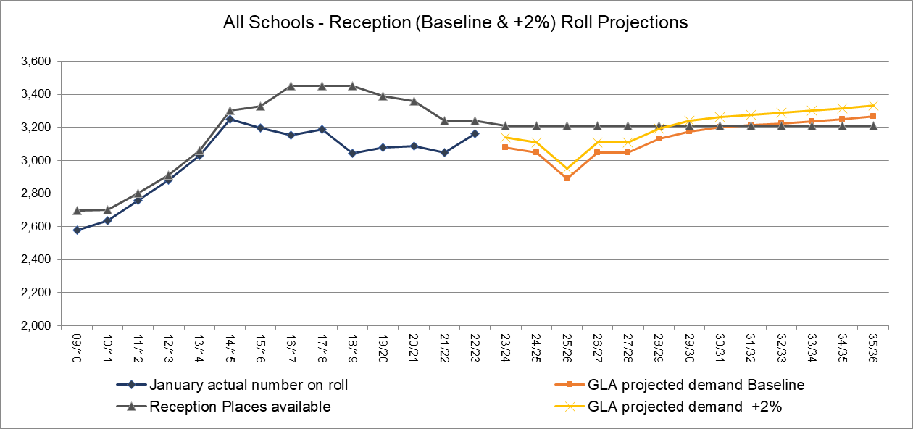
Source: SRP_borough_Spring2023_3_1_BPO202110-year_constrained_1805230626

3.4 Primary School Projections by Planning Area

Map showing the new (May 2022) ward boundaries and primary planning areas for Harrow
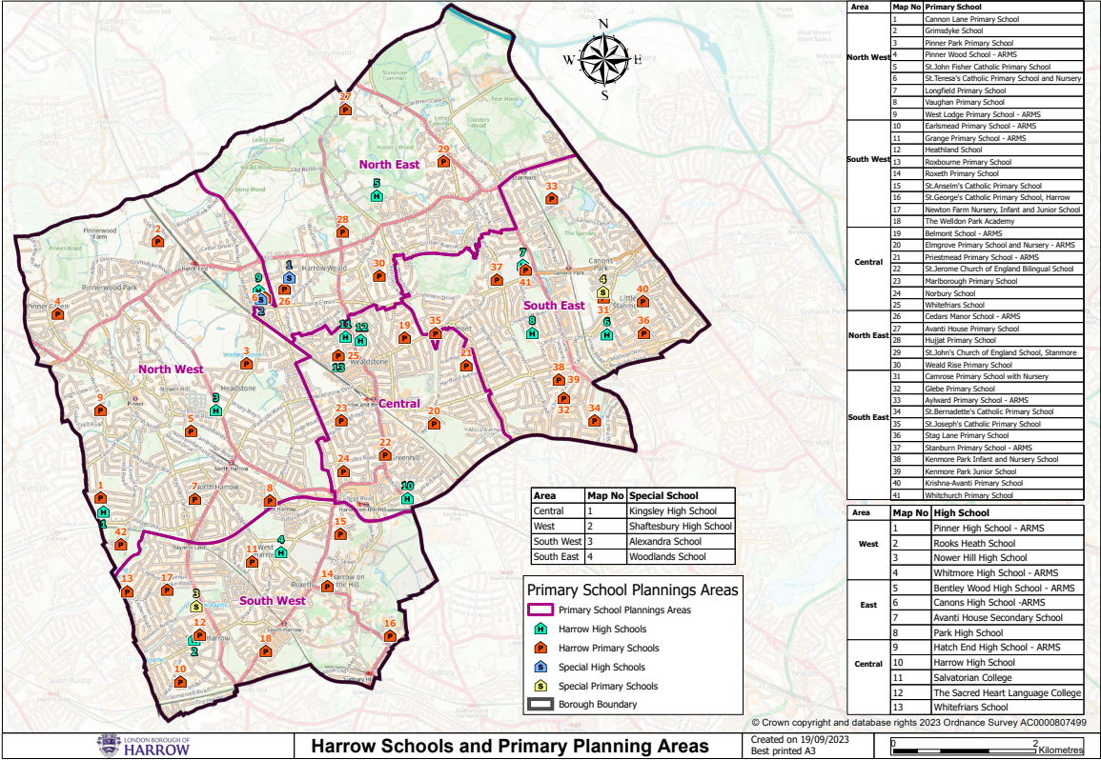
North East Planning Area (GLA Planning Area 1):
The North East Planning Area is made up of six primary schools (see table below), which have a combined PAN of 360. The numbers on roll in the Reception to Year 6 groups has fallen over the last few years and have fluctuated in the Reception Year, as can be seen in the tables below. There are enough places to accommodate the projected demand for this planning area for the forthcoming years.

Main wards | Harrow Weald, Stanmore
Schools (PAN) | Avanti House (60), Cedars Manor* (60), Hujjat Primary (60), St John’s CofE (60), St Teresa’s (60), Weald Rise** (60)
Total PAN | 360
*Cedars Manor formal PAN reduction from 3FE to 2FE from 2019/20; **Weald Rise formal PAN reduction from 4FE to 2FE (120 to 60) from 2020/21

Table 6: Primary projections for the North East Planning Area
Primary projection area: North East (Community Schools only) – Years R to 6 only
Year | January actual number on roll | Projected demand GLA (Baseline) | Projected demand GLA (R+2% - Yr6) | Places available | Surplus /Shortfall of places (Baseline) | Surplus /Shortfall of places (R+2% - Yr6)
15/16 | 2,313
16/17 | 2,294
17/18 | 2,247
18/19 | 2,201
19/20 | 2,103
20/21 | 2,015
21/22 | 2,007
22/23 | 2,104
23/24 |  | 2,173 | 2,216 | 2,340 | 167 | 124
24/25 |  | 2,217 | 2,261 | 2,400 | 183 | 139
25/26 |  | 2,253 | 2,298 | 2,460 | 207 | 162
26/27 |  | 2,293 | 2,339 | 2,520 | 227 | 181
27/28 |  | 2,306 | 2,352 | 2,520 | 214 | 168
28/29 |  | 2,297 | 2,343 | 2,520 | 223 | 177
29/30 |  | 2,270 | 2,315 | 2,520 | 250 | 205
30/31 |  | 2,256 | 2,301 | 2,520 | 264 | 219
31/32 |  | 2,259 | 2,304 | 2,520 | 261 | 216
32/33 |  | 2,269 | 2,314 | 2,520 | 251 | 206
33/34 |  | 2,274 | 2,319 | 2,520 | 246 | 201
34/35 |  | 2,284 | 2,330 | 2,520 | 236 | 190
35/36 |  | 2,289 | 2,335 | 2,520 | 231 | 185
Source: SRP_borough_Spring2023_3_1_BPO202110-year_constrained_1805230626
Table 3 above shows the Reception (Baseline & +2%) to Year 6 GLA roll projections for the North East Planning Area. The actual number of pupils have continued decreasing from 2,313 in 2015/16 to 2,007 pupils in 2021/22 but increased to 2,104 in 2022/23. The projections for this area start at 2,173 (Baseline) and 2,216 (+2%) for 2023/24 and overall continue increasing to 2,289 (Baseline) and 2,235 (+2%) in 2035/36. A surplus of places is projected for the whole of the 2023/24 to 2035/36 period.
Table 7: Reception Projections for the North East Planning Area
Primary Planning Area 1 - North East (Community Schools only) – Year Reception
School Year | January actual number on roll | Projected demand GLA (Baseline) | Projected demand GLA (+2%) | Reception Places available | Calculated FE - baseline | Calculated FE +2% | Proposed Additional FE required  Baseline & +2%
15/16 | 343
16/17 | 287
17/18 | 292
18/19 | 277
19/20 | 271
20/21 | 291
21/22 | 314
22/23 | 351
23/24 |  | 345 | 352 | 360 | 0.50 | 0.27 | 0
24/25 |  | 327 | 334 | 360 | 1.10 | 0.88 | 0
25/26 |  | 313 | 319 | 360 | 1.57 | 1.36 | 0
26/27 |  | 324 | 330 | 360 | 1.20 | 0.98 | 0
27/28 |  | 320 | 326 | 360 | 1.33 | 1.12 | 0
28/29 |  | 325 | 332 | 360 | 1.17 | 0.95 | 0
29/30 |  | 327 | 334 | 360 | 1.10 | 0.88 | 0
30/31 |  | 327 | 334 | 360 | 1.10 | 0.88 | 0
31/32 |  | 326 | 333 | 360 | 1.13 | 0.92 | 0
32/33 |  | 326 | 333 | 360 | 1.13 | 0.92 | 0
33/34 |  | 327 | 334 | 360 | 1.10 | 0.88 | 0
34/35 |  | 328 | 335 | 360 | 1.07 | 0.85 | 0
35/36 |  | 328 | 335 | 360 | 1.07 | 0.85 | 0
Source: SRP_borough_Spring2023_3_1_BPO202110-year_constrained_1805230626

Table 4 above and Chart 3 below show the GLA roll projections for the Reception year group for the North East Planning Area. The actual number on roll increased by over 1 form of entry from 314 in 2021/22 to 351 in 2022/23. Future numbers for the area are projected to drop slightly over the period covered, from 345 (Baseline) and 360 (+2%) in 2023/24 to 328 (Baseline) and 335 (+2%) by 2035/36. There is projected to be a surplus of up to 1.5 forms of entry in this area.
Chart 3: Current number on roll compared to roll projections and places available for the North East Planning Area
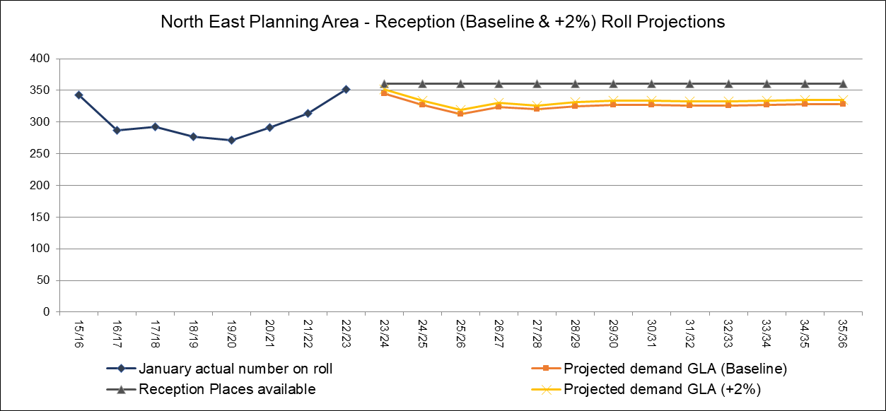
Source: SRP_borough_Spring2023_3_1_BPO202110-year_constrained_1805230626

North West Planning Area (GLA Planning Area 2):

The North West Planning Area is made up of eight primary schools (see table below), which have a combined PAN of 780. The numbers on roll in the Reception to Year 6 groups have continued to increase over the last eight years and have fluctuated in the Reception Year, as can be seen in the tables below. There are enough places to accommodate the projected demand for this planning area for the forthcoming years.

Main wards | Hatch End, Headstone, Pinner, Pinner South, North Harrow
Schools (PAN) | Cannon Lane (120), Grimsdyke (90), Longfield (90), Pinner Park (120), Pinner Wood (90), St John Fisher (90), Vaughan (90), West Lodge (90)
Total PAN | 780

Table 8: Primary projections for the North West Planning Area
Primary projection area: North West (Community Schools only) – Years R to 6 only
Year | January actual number on roll | Projected demand GLA (Baseline) | Projected demand GLA (R+2% - Yr6) | Places available | Surplus /Shortfall of places (Baseline) | Surplus /Shortfall of places (R+2% - Yr6)
15/16 | 4,148
16/17 | 4,290
17/18 | 4,347
18/19 | 4,549
19/20 | 5,480
20/21 | 5,533
21/22 | 5,508
22/23 | 5,510
23/24 |  | 5,487 | 5,597 | 5,550 | 63 | -47
24/25 |  | 5,415 | 5,523 | 5,520 | 105 | -3
25/26 |  | 5,320 | 5,426 | 5,490 | 170 | 64
26/27 |  | 5,232 | 5,337 | 5,460 | 228 | 123
27/28 |  | 5,132 | 5,235 | 5,430 | 298 | 195
28/29 |  | 5,098 | 5,200 | 5,460 | 362 | 260
29/30 |  | 5,048 | 5,149 | 5,460 | 412 | 311
30/31 |  | 5,022 | 5,122 | 5,460 | 438 | 338
31/32 |  | 5,018 | 5,118 | 5,460 | 442 | 342
32/33 |  | 5,041 | 5,142 | 5,460 | 419 | 318
33/34 |  | 5,048 | 5,149 | 5,460 | 412 | 311
34/35 |  | 5,063 | 5,164 | 5,460 | 397 | 296
35/36 |  | 5,078 | 5,180 | 5,460 | 382 | 280
Source: SRP_borough_Spring2023_3_1_BPO202110-year_constrained_1805230626
Table 5 above shows that the Reception to Year 6 number on rolls for this planning area have continued to increase from 4,148 in 2015/16 to 5,510 in 2022/23. The Baseline and +2% projections decrease from 5,487 (Baseline) & 5,597 (+2%) in 2023/24 to 5,078 (Baseline) & 5,180 (+2%) in 2035/36. There is a surplus of places projected for this area.
Table 9: Reception Projections for the North West Planning Area
Primary Planning Area 2 - North West (Community Schools only) – Year Reception
School Year | January actual number on roll | Projected demand GLA (Baseline) | Projected demand GLA (+2%) | Reception Places available | Calculated FE - baseline | Calculated FE +2% | Proposed Additional FE required  Baseline & +2% | Total Reception Places Proposed - baseline & +2%
15/16 | 681
16/17 | 670
17/18 | 661
18/19 | 655
19/20 | 797
20/21 | 775
21/22 | 735
22/23 | 778
23/24 |  | 764 | 779 | 780 | 0.53 | 0.02 | 0 | 780
24/25 |  | 747 | 762 | 780 | 1.10 | 0.60 | 0 | 780
25/26 |  | 713 | 727 | 780 | 2.23 | 1.76 | 0 | 780
26/27 |  | 747 | 762 | 780 | 1.10 | 0.60 | 0 | 780
27/28 |  | 739 | 754 | 780 | 1.37 | 0.87 | 0 | 780
28/29 |  | 750 | 765 | 780 | 1.00 | 0.50 | 0 | 780
29/30 |  | 751 | 766 | 780 | 0.97 | 0.47 | 0 | 780
30/31 |  | 748 | 763 | 780 | 1.07 | 0.57 | 0 | 780
31/32 |  | 745 | 760 | 780 | 1.17 | 0.67 | 0 | 780
32/33 |  | 743 | 758 | 780 | 1.23 | 0.74 | 0 | 780
33/34 |  | 743 | 758 | 780 | 1.23 | 0.74 | 0 | 780
34/35 |  | 745 | 760 | 780 | 1.17 | 0.67 | 0 | 780
35/36 |  | 747 | 762 | 780 | 1.10 | 0.60 | 0 | 780
Source: SRP_borough_Spring2023_3_1_BPO202110-year_constrained_1805230626

Table 6 above and Chart 4 show that the actual numbers on roll for this planning area have fluctuated over the last few years but increased to 778 in 2022/23. The projections for this area gradually decrease from 764 (Baseline) & 779 (+2%) in 2023/24 to 747 (Baseline) & 762 (+2%) in 2035/36. There is a projected surplus of places in for this area.

Chart 4: Current number on roll compared to roll projections and places available for the North West Planning Area
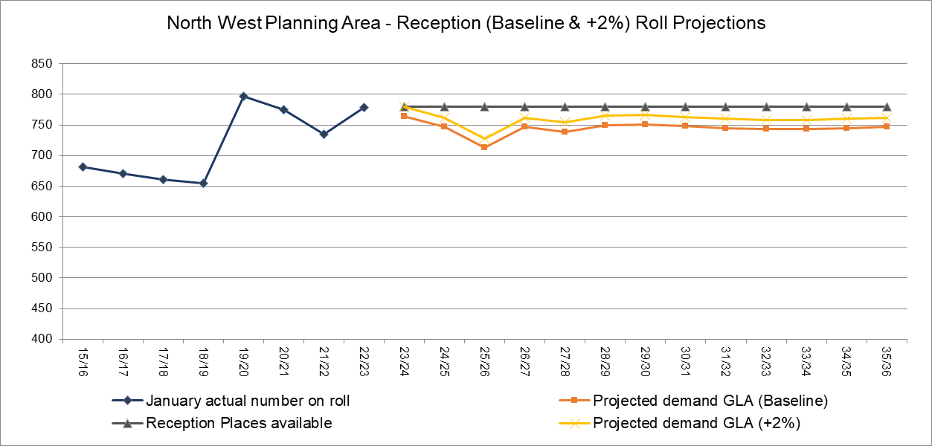
Source: SRP_borough_Spring2023_3_1_BPO202110-year_constrained_1805230626

South East Planning Area (GLA Planning Area 3):

The South East Planning Area is made up of ten primary schools (see table below), which have a combined PAN of 780. The numbers on roll in the Reception to Year 6 groups have fluctuated over the last eight years and have fluctuated in the Reception Year, as can be seen in the tables below. There are enough places to accommodate the projections for this planning area for the forthcoming years.
Main wards | Belmont, Canons, Centenary, Edgware, Kenton East
Schools (PAN) | Aylward (90), Camrose (60), Glebe (90), Kenmore Parks (90), Krishna Avanti (60), St Bernadette’s (60), Stag Lane (120), Stanburn (90), Whitchurch (120)
Total PAN | 780

Table 10: Primary projections for the South East Planning Area
Primary projection area: South East (Community Schools only) – Years R to 6 only
Year | January actual number on roll | Projected demand GLA (Baseline) | Projected demand GLA (R+2% - Yr6) | Places available | Surplus /Shortfall of places (Baseline) | Surplus /Shortfall of places (R+2% - Yr6)
15/16 | 5,001
16/17 | 5,181
17/18 | 5,213
18/19 | 5,279
19/20 | 5,290
20/21 | 5,203
21/22 | 5,115
22/23 | 5,202
23/24 |  | 5,212 | 5,316 | 5,610 | 398 | 294
24/25 |  | 5,176 | 5,280 | 5,580 | 404 | 300
25/26 |  | 5,075 | 5,177 | 5,550 | 475 | 374
26/27 |  | 5,011 | 5,111 | 5,520 | 509 | 409
27/28 |  | 4,936 | 5,035 | 5,490 | 554 | 455
28/29 |  | 4,868 | 4,965 | 5,460 | 592 | 495
29/30 |  | 4,808 | 4,904 | 5,460 | 652 | 556
30/31 |  | 4,779 | 4,875 | 5,460 | 681 | 585
31/32 |  | 4,765 | 4,860 | 5,460 | 695 | 600
32/33 |  | 4,782 | 4,878 | 5,460 | 678 | 582
33/34 |  | 4,789 | 4,885 | 5,460 | 671 | 575
34/35 |  | 4,810 | 4,906 | 5,460 | 650 | 554
35/36 |  | 4,822 | 4,918 | 5,460 | 638 | 542
Source: SRP_borough_Spring2023_3_1_BPO202110-year_constrained_1805230626
Table 7 above shows the actual number on roll and projection figures for the South East Planning Area for Reception to Year 6. The actual number of pupils have fluctuated over the last few years, increasing from 5,115 in 2021/22 to 5,202 in 2022/23. The projections for this area drop from 5,212 (Baseline) and 5,316 (+2%) in 2023/24 and drop to 4,822 (Baseline) and 4,918 (+2%) in 2035/36. There is a surplus of places in this planning area for the entire period covered.

Table 11: Reception Projections for the South East Planning Area
Primary Planning Area 3 - South East (Community Schools only) - Year Reception
School Year | January actual number on roll | Projected demand GLA (Baseline) | Projected demand GLA (+2%) | Reception Places available | Calculated FE - baseline | Calculated FE +2% | Proposed Additional FE required  Baseline & +2% | Total Reception Places Proposed - baseline & +2%
15/16 | 762
16/17 | 775
17/18 | 801
18/19 | 757
19/20 | 733
20/21 | 752
21/22 | 756
22/23 | 758
23/24 |  | 720 | 734 | 780 | 2.00 | 1.52 | 0 | 780
24/25 |  | 718 | 732 | 780 | 2.07 | 1.59 | 0 | 780
25/26 |  | 672 | 685 | 780 | 3.60 | 3.15 | 0 | 780
26/27 |  | 691 | 705 | 780 | 2.97 | 2.51 | 0 | 780
27/28 |  | 682 | 696 | 780 | 3.27 | 2.81 | 0 | 780
28/29 |  | 692 | 706 | 780 | 2.93 | 2.47 | 0 | 780
29/30 |  | 694 | 708 | 780 | 2.87 | 2.40 | 0 | 780
30/31 |  | 691 | 705 | 780 | 2.97 | 2.51 | 0 | 780
31/32 |  | 689 | 703 | 780 | 3.03 | 2.57 | 0 | 780
32/33 |  | 687 | 701 | 780 | 3.10 | 2.64 | 0 | 780
33/34 |  | 688 | 702 | 780 | 3.07 | 2.61 | 0 | 780
34/35 |  | 689 | 703 | 780 | 3.03 | 2.57 | 0 | 780
35/36 |  | 692 | 706 | 780 | 2.93 | 2.47 | 0 | 780
Source: SRP_borough_Spring2023_3_1_BPO202110-year_constrained_1805230626

Table 8 above and Chart 5 below show that even though the Reception numbers on roll have fluctuated a little over the period shown, they have overall remained quite stable, at 758 in 2022/23 in the South East planning area. The projections in this area start at 720 (Baseline) and 734 (+2%) in 2023/24 but steadily continue to fall over the period dropping to 692 (Baseline) and 706 (+2%) in 2035/36. There is a sufficient number of places available in this area.

Chart 5: Current number on roll compared to roll projections and places available for the South East Planning Area
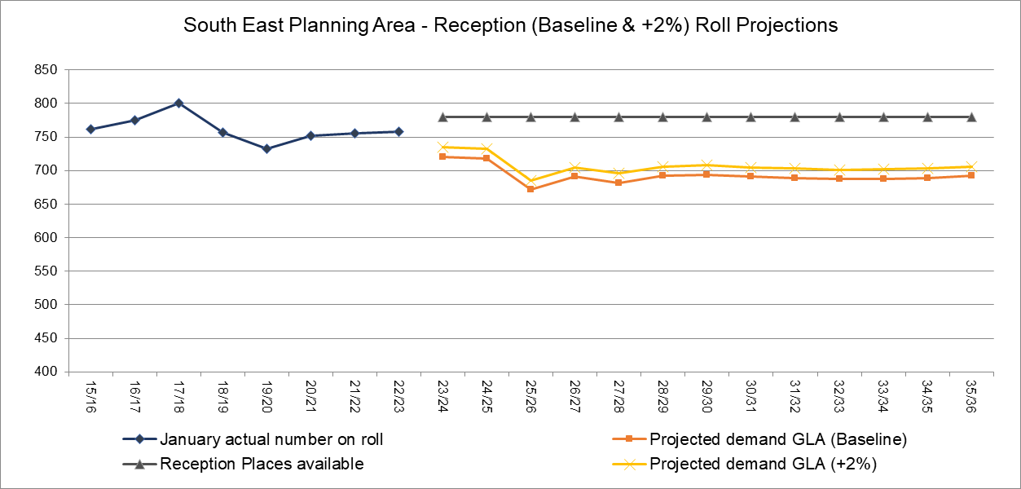
Source: SRP_borough_Spring2023_3_1_BPO202110-year_constrained_1805230626

South West Planning Area (GLA Planning Area 4):
The South West Planning Area is made up of nine primary schools (see table below), which have a combined PAN of 600. The numbers on roll in the Reception to Year 6 groups have fluctuated over the last eight years and have fluctuated in the Reception Year, as can be seen in the tables below. There are enough places to accommodate the projections for this planning area for the forthcoming years.
Main wards | Harrow on the Hill, Rayners Lane, Roxbourne, Roxeth, West Harrow
Schools (PAN) | Earlsmead (60), Grange (90), Heathland (90), Newton Farm (60), Roxbourne (60), Roxeth (60), Welldon Park (60), St Anselm’s (60), St George’s (60)
Total PAN | 600

Table 12: Primary projections for the South West Planning Area
Primary projection area: South West (Community Schools only) – Years R to 6 only
Year | January actual number on roll | Projected demand GLA (Baseline) | Projected demand GLA (R+2% - Yr6) | Places available | Surplus /Shortfall of places (Baseline) | Surplus /Shortfall of places (R+2% - Yr6)
15/16 | 4,296
16/17 | 4,157
17/18 | 4,118
18/19 | 4,129
19/20 | 4,076
20/21 | 3,959
21/22 | 3,924
22/23 | 3,901
23/24 |  | 3,888 | 3,966 | 4,170 | 282 | 204
24/25 |  | 3,844 | 3,921 | 4,140 | 296 | 219
25/26 |  | 3,801 | 3,877 | 4,110 | 309 | 233
26/27 |  | 3,794 | 3,870 | 4,080 | 286 | 210
27/28 |  | 3,781 | 3,857 | 4,050 | 269 | 193
28/29 |  | 3,776 | 3,852 | 4,020 | 244 | 168
29/30 |  | 3,769 | 3,844 | 3,990 | 221 | 146
30/31 |  | 3,777 | 3,853 | 3,990 | 213 | 137
31/32 |  | 3,788 | 3,864 | 3,990 | 202 | 126
32/33 |  | 3,823 | 3,899 | 3,990 | 167 | 91
33/34 |  | 3,841 | 3,918 | 3,990 | 149 | 72
34/35 |  | 3,869 | 3,946 | 3,990 | 121 | 44
35/36 |  | 3,886 | 3,964 | 3,990 | 104 | 26
Source: SRP_borough_Spring2023_3_1_BPO202110-year_constrained_1805230626
Table 9 above shows the number of Reception to Year 6 pupils in the South West Planning Area. Pupil numbers in this area have dropped from 4,296 in 2015/16 to 3,901 pupils in 2022/23. The projections for this area remain relatively stable at 3,888 (Baseline) and 3,966 (+2%) in 2023/24 and at 3,886 (Baseline) and 3,964 (+2%) by 2035/36. There is a surplus of places in this area.
Table 13: Reception Projections for the South West Planning Area
Primary Planning Area 4 - South West (Community Schools only) - Year Reception
Year Reception
School Year | January actual number on roll | Projected demand GLA (Baseline) | Projected demand GLA (+2%) | Reception Places available | Calculated FE - baseline | Calculated FE +2% | Proposed Additional FE required  Baseline & +2% | Total Reception Places Proposed - baseline & +2%
15/16 | 609
16/17 | 567
17/18 | 575
18/19 | 550
19/20 | 559
20/21 | 558
21/22 | 536
22/23 | 560
23/24 |  | 558 | 569 | 570 | 0.40 | 0.03 | 0 | 570
24/25 |  | 555 | 566 | 570 | 0.50 | 0.13 | 0 | 570
25/26 |  | 521 | 531 | 570 | 1.63 | 1.29 | 0 | 570
26/27 |  | 550 | 561 | 570 | 0.67 | 0.30 | 0 | 570
27/28 |  | 551 | 562 | 570 | 0.63 | 0.27 | 0 | 570
28/29 |  | 564 | 575 | 570 | 0.20 | -0.18 | 0 | 570
29/30 |  | 569 | 580 | 570 | 0.03 | -0.35 | 0 | 570
30/31 |  | 572 | 583 | 570 | -0.07 | -0.45 | 0 | 570
31/32 |  | 572 | 583 | 570 | -0.07 | -0.45 | 0 | 570
32/33 |  | 573 | 584 | 570 | -0.10 | -0.48 | 0 | 570
33/34 |  | 574 | 585 | 570 | -0.13 | -0.52 | 0/1 | 600
34/35 |  | 576 | 588 | 570 | -0.20 | -0.58 | 0/1 | 600
35/36 |  | 579 | 591 | 570 | -0.30 | -0.69 | 0/1 | 600
Source: SRP_borough_Spring2023_3_1_BPO202110-year_constrained_1805230626

Table 10 above and Chart 6 below show the Reception numbers and projections in the South West planning area. The actual pupil numbers for this area have fluctuated over the last few years, however they increased to 560 in 2022/23. The projections for this area are projected to fall but then rise over the period covered, from 558 (Baseline) and 569 (+2%) in 2023/24 to 579 (Baseline) and 591 (+2%) in 2035/36. There is a very small projected surplus of places until 2027/28, which becomes a Shortfall of just under 1 form of entry.

Chart 6: Current number on roll compared to roll projections and places available for the South West Planning Area
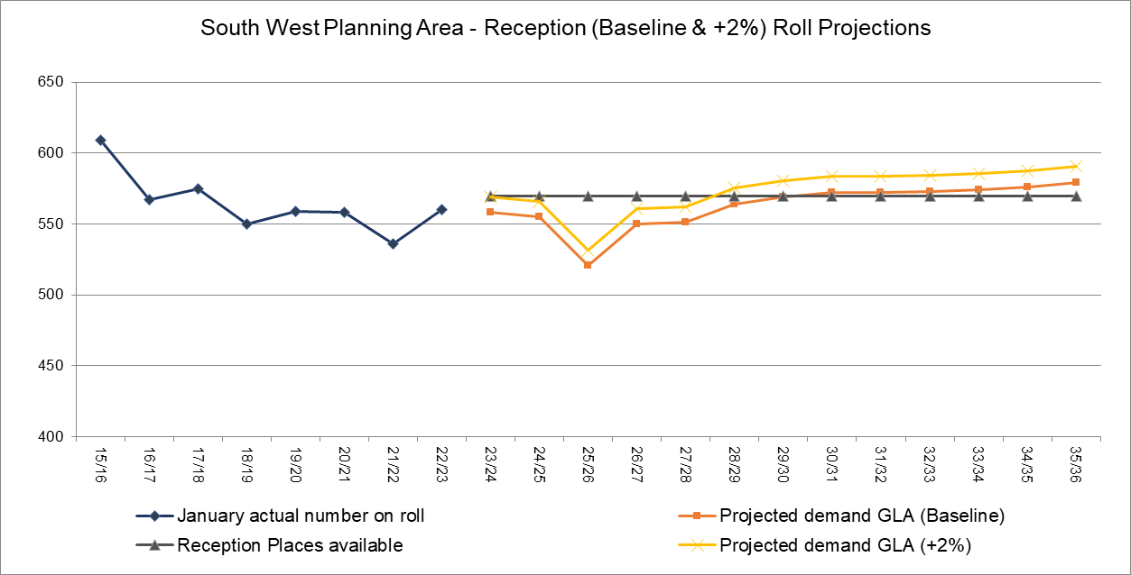
Source: SRP_borough_Spring2023_3_1_BPO202110-year_constrained_1805230626

Central Planning Area (GLA Planning Area 5):

The Central Planning Area is made up of eight primary schools (see table below), which have a combined PAN of 720. The numbers on roll in the Reception to Year 6 groups have fluctuated over the last eight years and they have also fluctuated in the Reception Year, as can be seen in the tables below. The table below shows that a shortfall is projected for the Reception to Year 6 places from 2025/26 onwards.
Main wards | Greenhill, Kenton West, Marlborough, Wealdstone North, Wealdstone South
Schools (PAN) | Belmont (90), Elmgrove (120), Marlborough (90), Norbury (90), Priestmead (120), Saint Jerome’s (60), St Joseph’s (60), Whitefriars (90)
Total PAN | 720

The Central Planning area is an area of significant housing development as part of Harrow’s Opportunity Area and the demand for places will be monitored closely. A Government free school Saint Jérôme Bilingual School, opened in September 2016, providing 2 forms of entry.

There is one further school in the Government’s Free School programme that will contribute to the provision of up to an additional 3 forms of entry in this Central Planning Area, Harrow View School. In the context of the potential child yield impact across year groups of the housing development programme, which will not be factored fully into the projections until the types of housing units is known and approved, the projected shortfall of places (R to Y6) will be monitored closely and be aligned with the opening of Harrow View.

Table 11 below shows the actual numbers and the projected Reception (Baseline & +2%) to Year 6 pupil numbers in the Central Planning Area up to 2035/36. The actual numbers on roll increased substantially in this area, from 4,799 in 2015/16 to 5,316 in 2018/19, and have started to increase again, to 4,844 in 2022/23. The projections for this area are projected to continue increasing, rising from 4,889 (Baseline) and 4,987 (+2%) in 2023/24 to 5,909 (Baseline) and 6,027 (+2%) by 2035/36. There are sufficient places in this area until 2027/28, at which point there is a projected shortfall of 39 (+2%) places. The shortfall in places is set to increase substantially over the period covered in the table, with the projections suggesting a shortfall of up to 869 Baseline and 987 places by 2035/36.

Table 14: Primary projections for the Central Planning Area
Primary projection area: Central (Community Schools) – Years R to 6 only
Year | January actual number on roll | Projected demand GLA (Baseline) | Projected demand GLA (R+2% - Yr6) | Places available | Surplus /Shortfall of places (Baseline) | Surplus /Shortfall of places (R+2% - Yr6)
15/16 | 4,799
16/17 | 5,019
17/18 | 5,232
18/19 | 5,316
19/20 | 4,659
20/21 | 4,749
21/22 | 4,768
22/23 | 4,844
23/24 |  | 4,889 | 4,987 | 5,040 | 151 | 53
24/25 |  | 4,889 | 4,987 | 5,040 | 151 | 53
25/26 |  | 4,888 | 4,986 | 5,040 | 152 | 54
26/27 |  | 4,921 | 5,019 | 5,040 | 119 | 21
27/28 |  | 4,979 | 5,079 | 5,040 | 61 | -39
28/29 |  | 5,094 | 5,196 | 5,040 | -54 | -156
29/30 |  | 5,218 | 5,322 | 5,040 | -178 | -282
30/31 |  | 5,368 | 5,475 | 5,040 | -328 | -435
31/32 |  | 5,494 | 5,604 | 5,040 | -454 | -564
32/33 |  | 5,634 | 5,747 | 5,040 | -594 | -707
33/34 |  | 5,736 | 5,851 | 5,040 | -696 | -811
34/35 |  | 5,833 | 5,950 | 5,040 | -793 | -910
35/36 |  | 5,909 | 6,027 | 5,040 | -869 | -987
Source: SRP_borough_Spring2023_3_1_BPO202110-year_constrained_1805230626
As can be seen by the shortfall of places projected in the table below the Central Planning area is an area of significant housing development, which is a part of Harrow’s Opportunity Area. The demand for places in this planning area are being closely monitored, with 3FE planned to meet the demand via the school proposed Harrow View Primary School.

Table 12 and Chart 7 below show that the number of Reception pupils in the Central planning area have significantly increased over the last few years. The Reception numbers in this area increased in 2016/17 due to the inclusion of the school places available at the St Jérôme Bilingual School, which opened in September 2016. However, the numbers started to drop after 2018/19, but have stabilised at in recent years, at 715 in 2022/23.

The projections for this planning area are projected to fluctuate for a couple of years and then start increasing, from 673 (Baseline) and 686 (+2%) in 2025/26 to 920 (Baseline) and 938 (+2%) by 2035/36. There is a projected shortfall of under 1 form of entry in 2026/27, which continues to increase to 7 FE by from 2035/36. However, it should be noted that the neighbouring planning areas have sufficient places.
Table 15: Reception Projections for the Central Planning Area
Primary Planning Area 5 – Central – Year Reception
School Year | January actual number on roll | Projected demand GLA (Baseline) | Projected demand GLA (+2%) | Reception Places available | Calculated FE - baseline | Calculated FE +2% | Proposed Additional FE required  Baseline/+2% | Total Reception Places Proposed - baseline | Total Reception Places Proposed - +2%
15/16 | 774
16/17 | 830
17/18 | 834
18/19 | 791
19/20 | 714
20/21 | 713
21/22 | 707
22/23 | 715
23/24 |  | 688 | 702 | 720 | 1.07 | 0.61 | 0 | 718 | 762
24/25 |  | 701 | 715 | 720 | 0.63 | 0.17 | 0 | 731 | 745
25/26 |  | 673 | 686 | 720 | 1.57 | 1.12 | 0 | 703 | 746
26/27 |  | 737 | 752 | 720 | -0.57 | -1.06 | 1/1 | 767 | 782
27/28 |  | 757 | 772 | 720 | -1.23 | -1.74 | 1/2 | 787 | 802
28/29 |  | 799 | 815 | 720 | -2.63 | -3.17 | 3/3 | 829 | 875
29/30 |  | 833 | 850 | 720 | -3.77 | -4.32 | 4/4 | 893 | 910
30/31 |  | 862 | 879 | 720 | -4.73 | -5.31 | 5/5 | 922 | 969
31/32 |  | 880 | 898 | 720 | -5.33 | -5.92 | 5/6 | 970 | 988
32/33 |  | 892 | 910 | 720 | -5.73 | -6.33 | 6/6 | 982 | 1,030
33/34 |  | 903 | 921 | 720 | -6.10 | -6.70 | 6/7 | 1,023 | 1,041
34/35 |  | 911 | 929 | 720 | -6.37 | -6.97 | 6/7 | 1,031 | 1,049
35/36 |  | 920 | 938 | 720 | -6.67 | -7.28 | 7/7 | 1,040 | 1,058
Source: SRP_borough_Spring2023_3_1_BPO202110-year_constrained_1805230626

Chart 7: Current number on roll compared to roll projections and places available for the Central Planning Area
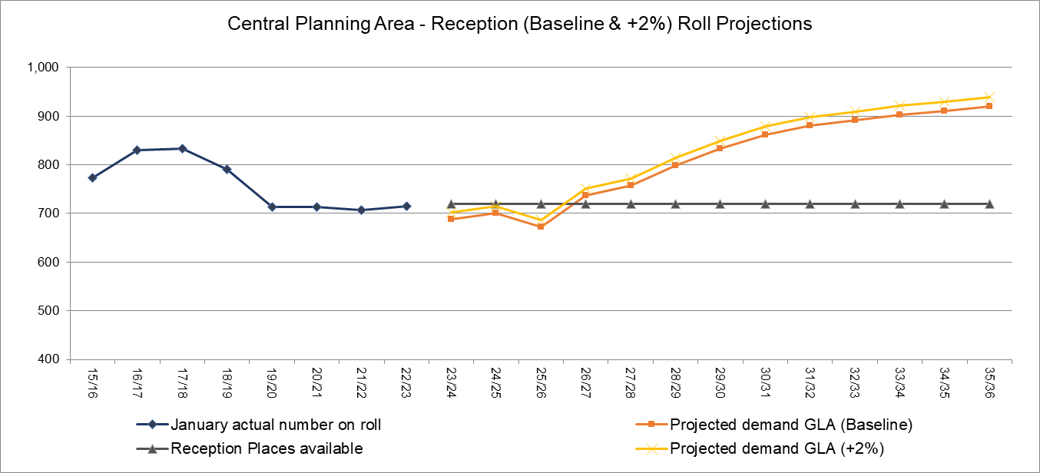
Source: SRP_borough_Spring2023_3_1_BPO202110-year_constrained_1805230626

3.5 Numbers on Roll in Secondary Schools
Harrow has 13 secondary schools (see table below), which have a combined PAN of 2,724 for September 2023. The numbers on roll in the Year 7 to Year 11 groups have consistently been increasing since 2013/14 from 10,342 to 13,393 in 2022/23. The Year 7 numbers on roll have overall continued increasing since 2021/13, with 2,667 pupils in 2022/23. The table below shows a shortfall is projected for the Year 7 to Year 11 places from 2025/26 onwards.

Schools (PAN) | Bentley Wood High (240), Canons High (210), Harrow High (180), Hatch End High (210), Nower Hill High (324), Park High (270), Rooks Heath College (210), Whitmore High (270), Salvatorian College (150), Sacred Heart Language College (150), Avanti House Secondary (180), Whitefriars (Secondary) (150), Pinner High (180)
Total PAN | 2,724

Secondary school roll projections are presented on the basis of Years 7 to 11 (11 to 15 year olds) and Year 7 in all Harrow schools. Generally secondary school place planning has been undertaken on a whole borough level. However, further analysis is being undertaken on three planning areas.

Currently Harrow has capacity within the high school sector because opportunities have been taken when available to increase school places to meet future projected shortfalls through government funding, though this is ahead of the student demand.

There is a significant level of new housing development planned in Harrow over the next few years. The types of housing units, and therefore the anticipated child yield, are not known at this stage. Of the latest projections in this report and announced free school, there are expected to be sufficient primary school places in Harrow to meet a significant level of child yield. New housing development can be expected to include students at secondary school age. Information for the early large housing developments will be clearer in the coming years.

3.6 Projections for Year 7 to Year 11 Secondary School Pupils

Table 13 and Chart 8 below show that the numbers on roll from Year 7 to Year 11 have continued increasing from 10,342 in 2013/14 to 13,393 in 2022/23. The GLA projections for Year 7 to Year 11 are projected to start dropping from 13,629 (Baseline) and 13,902 (+2%) in 2024/25 to 11,841 (Baseline) and 12,078 (+2%) by 2035/36. With the exception of 2024/25 there is a surplus of places projected over the period shown in the table below.

Table 16: Secondary projections for Year 7 (Baseline & +2%) to Year 11 in all High Schools
Secondary projections: All High Schools – Years 7 to 11 only
Year | January actual number on roll | Projected demand GLA (Yr 7 Baseline) | Projected demand GLA (Yr 7 +2%) | Places available | Number of Surplus places (Yr 7 Baseline) | Number of Surplus places (Yr 7 +2%) | Forms of Entry surplus/Shortfall (Yr 7 Baseline) | Forms of Entry surplus/Shortfall (Yr 7 +2%)
10/11 | 10,473 |  |  | 11,040 | 567
11/12 | 10,556 |  |  | 11,130 | 574
12/13 | 10,368 |  |  | 11,340 | 972
13/14 | 10,342 |  |  | 11,510 | 1,168
14/15 | 10,500 |  |  | 11,650 | 1,150
15/16 | 10,686 |  |  | 11,730 | 1,044
16/17 | 10,983 |  |  | 12,110 | 1,127
17/18 | 11,234 |  |  | 12,474 | 1,240
18/19 | 11,897 |  |  | 12,928 | 1,031
19/20 | 12,453 |  |  | 13,276 | 823
20/21 | 12,829 |  |  | 13,582 | 753
21/22 | 13,057 |  |  | 13,648 | 591
22/23 | 13,393 |  |  | 13,646 | 253
23/24 |  | 13,620 | 13,892 | 13,632 | 12 | -260 | 0 | -9
24/25 |  | 13,629 | 13,902 | 13,618 | -11 | -284 | 0 | -9
25/26 |  | 13,546 | 13,817 | 13,604 | 58 | -213 | 2 | -7
26/27 |  | 13,429 | 13,698 | 13,620 | 191 | -78 | 6 | -3
27/28 |  | 13,291 | 13,557 | 13,620 | 329 | 63 | 11 | 2
28/29 |  | 13,132 | 13,395 | 13,620 | 488 | 225 | 16 | 8
29/30 |  | 12,931 | 13,190 | 13,620 | 689 | 430 | 23 | 14
30/31 |  | 12,725 | 12,980 | 13,620 | 895 | 641 | 30 | 21
31/32 |  | 12,500 | 12,750 | 13,620 | 1120 | 870 | 37 | 29
32/33 |  | 12,173 | 12,416 | 13,620 | 1447 | 1204 | 48 | 40
33/34 |  | 11,989 | 12,229 | 13,620 | 1631 | 1391 | 54 | 46
34/35 |  | 11,857 | 12,094 | 13,620 | 1763 | 1526 | 59 | 51
35/36 |  | 11,841 | 12,078 | 13,620 | 1779 | 1542 | 59 | 51
Source: SRP_borough_Spring2023_3_1_BPO202110-year_constrained_1805230626

Chart 8: Current NOR compared to roll projections and places available for all Secondary Schools, Years 7 to 11
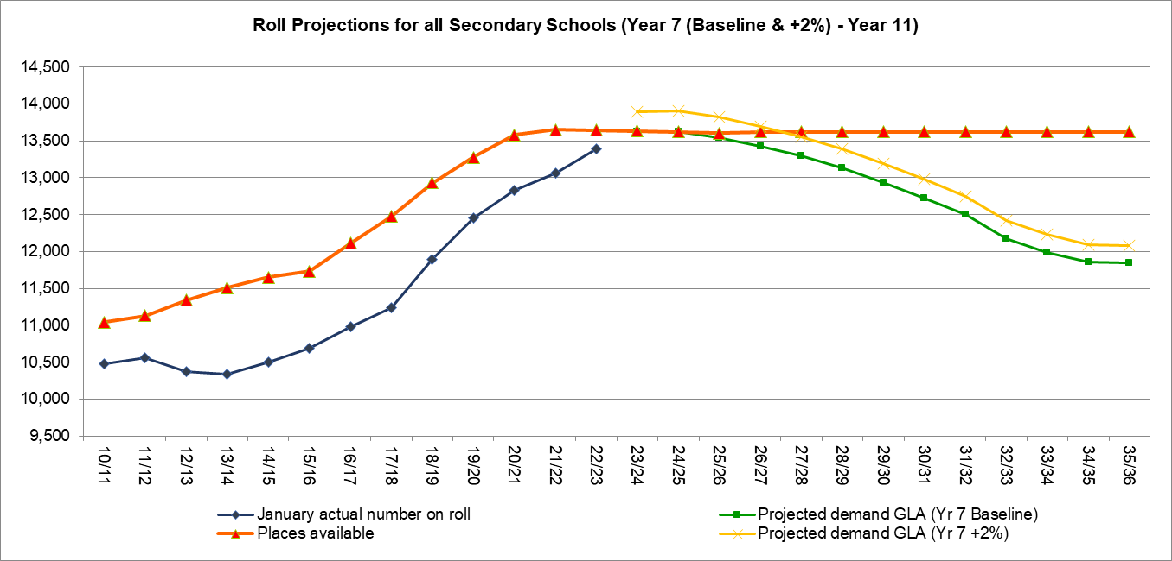
Source: SRP_borough_Spring2023_3_1_BPO202110-year_constrained_1805230626

3.7 Projections for Year 7 Secondary School Pupils

Table 14 and Chart 9 below show that Year 7 numbers on roll have overall continued increasing over the period shown in the table below, with 2,667 pupils on roll in 2022/23. The GLA projections are suggesting a gradual decline in the number of pupils, from 2,663 (Baseline) and 2,716 (+2%) in 2023/24 to 2,357 (Baseline) and 2,404 (+2%) in 2035/36. A surplus of places is suggested for the whole of the period shown in the table below.

Table 17: Secondary projections for Year 7 in all High Schools
Secondary projection area: All Schools (Includes VA) – Year 7
Year | January actual number on roll | GLA projected demand Baseline | GLA projected demand +2% | Year 7 Places available | Calculated FE Baseline | Proposed Additional FE required Baseline | Calculated FE +2% | Proposed Additional FE required +2% | Total Year 7 Places Proposed Baseline | Total Year 7 Places Proposed +2%
10/11 | 1,992
11/12 | 2,084
12/13 | 1,932
13/14 | 1,982
14/15 | 2,160
15/16 | 2,204
16/17 | 2,379
17/18 | 2,346
18/19 | 2,532
19/20 | 2,670
20/21 | 2,622
21/22 | 2,631
22/23 | 2,667
23/24 |  | 2,663 | 2,716 | 2,724 | 2.03 | 0 | 0.26 | 0 | 2,724 | 2,724
24/25 |  | 2,641 | 2,694 | 2,724 | 2.77 | 0 | 1.01 | 0 | 2,724 | 2,724
25/26 |  | 2,581 | 2,633 | 2,724 | 4.77 | 0 | 3.05 | 0 | 2,724 | 2,724
26/27 |  | 2,548 | 2,599 | 2,724 | 5.87 | 0 | 4.17 | 0 | 2,724 | 2,724
27/28 |  | 2,546 | 2,597 | 2,724 | 5.93 | 0 | 4.24 | 0 | 2,724 | 2,724
28/29 |  | 2,502 | 2,552 | 2,724 | 7.40 | 0 | 5.73 | 0 | 2,724 | 2,724
29/30 |  | 2,436 | 2,485 | 2,724 | 9.60 | 0 | 7.98 | 0 | 2,724 | 2,724
30/31 |  | 2,373 | 2,420 | 2,724 | 11.70 | 0 | 10.12 | 0 | 2,724 | 2,724
31/32 |  | 2,338 | 2,385 | 2,724 | 12.87 | 0 | 11.31 | 0 | 2,724 | 2,724
32/33 |  | 2,239 | 2,284 | 2,724 | 16.17 | 0 | 14.67 | 0 | 2,724 | 2,724
33/34 |  | 2,320 | 2,366 | 2,724 | 13.47 | 0 | 11.92 | 0 | 2,724 | 2,724
34/35 |  | 2,306 | 2,352 | 2,724 | 13.93 | 0 | 12.40 | 0 | 2,724 | 2,724
35/36 |  | 2,357 | 2,404 | 2,724 | 12.23 | 0 | 10.66 | 0 | 2,724 | 2,724
SRP_borough_Spring2023_3_1_BPO202110-year_constrained_1805230626

Chart 9: Current NOR compared to roll projections and places available for all High schools, Year 7 (Baseline & +2%)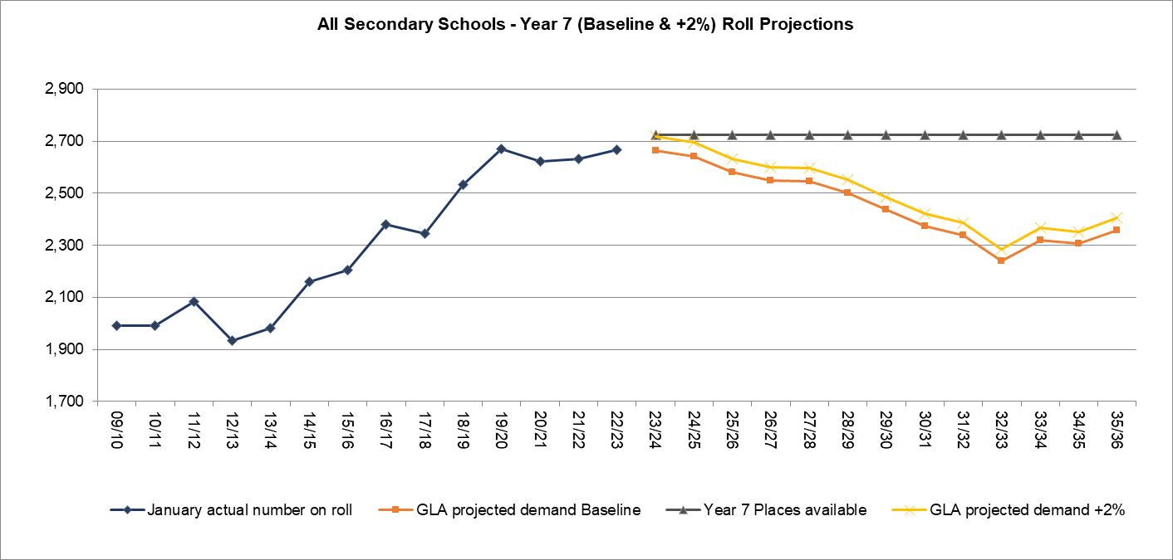
SRP_borough_Spring2023_3_1_BPO202110-year_constrained_1805230626

4.0 Demand for Special Education Need Specialist Provision
The number of children with SEN and those with an Education, Health and Care Plan has increased year on year. In 2014 the SEND legislation changed, and Statements of SEN were replaced by EHCPs. A key change was the raising of the age limit for those who could be in receipt of a plan from 19 to 25. The SEND reforms initially resulted in an increase in the numbers of children aged 20-25 with EHCPs, however these numbers have started to settle now that the oldest learners have moved out of education. The number of pupils with EHCPs in the early years, primary and secondary phases has also increased.
Additionally, the 2014 legislation lowered the thresholds for awarding an EHCP and an increasing number of children now meet the threshold, this has also contributed to the number of EHCP assessments rising. Notwithstanding this, the number of children and young people presenting with complex needs is rising, the number of ASD diagnoses is rising, and the number of young people with deteriorating mental health is rising, also leading to an increased number of EHCPs.
The trends over the last decade show that regardless of the numbers of Children and Young People in Harrow’s population fluctuating, the number of EHCPs in Harrow have continued to increase. This has created an on-going pressure on the number of finite specialist places available, therefore, any increase in the number of EHCPs in a year will create more pressure on an already overburdened system. Special schools, including the more expensive places outside of the borough or in the independent sector, are already full to capacity, which in turn is creating more pressure on mainstream schools who have children on their roll whose needs they are unable to fully meet.
The most significant impact of this is on the increased demand for specialist education. The demand for placements in special schools is rising beyond the LA capacity to meet need. The LA has had 3 bids rejected by the DfE for free special schools and is currently looking at alternative options to increase specialist provision for Harrow.
4.1 EHCPs maintained by Harrow
Harrow has increased the number of places at special schools and the number of additionally resourced places over the years. The Local Authority in accordance with Harrow SEND strategy is working with schools and stakeholders to increase this capacity to meet the rising demand. However, there is a continuing pressure on special provision, specifically for pupils with Severe Learning Difficulties (SLD) and complex needs, including autistic spectrum disorder (ASD), which is in line with what is happening nationally and across London.
The 2022 SEN2 return reported 2,094 children with EHCPs. This is an increase of 6% from 2022. EHCPs have consistently been increasing since 2010 and increased by 27% over the last 5 years since January 2019, as can be seen in the table below.

Table 18: Harrow’s Total Number of EHCPs by Age Group
Year | Total EHCPs | % increase | under 5 | 5-10yrs | 11-15yrs | 16-19yrs | 20-25
2015 | 1,336 | - | 75 | 503 | 518 | 227 | 13
2016 | 1,477 | 10.6% | 90 | 529 | 519 | 299 | 40
2017 | 1,623 | 9.0% | 104 | 562 | 543 | 322 | 92
2018 | 1,645 | 2.2% | 95 | 604 | 542 | 322 | 82
2019 | 1,798 | 9.4% | 100 | 652 | 575 | 351 | 120
2020 | 1,896 | 5.4% | 77 | 720 | 596 | 377 | 126
2021 | 1,974 | 4.1% | 76 | 760 | 631 | 391 | 116
2022 | 2,094 | 6.0% | 93 | 799 | 688 | 396 | 118
Source: DfE SEN2 return
An increasing number of children have been placed in independent special schools (with a consequential impact on the high needs block Shortfall) in an attempt to meet the demand, but most schools are now at capacity. The LA is developing mainstream specialist provision, but this will not resolve the issue.
The numbers of requests for EHC needs assessment have risen and continue to do so. The rate of increase of requests received has fluctuated, but the rise this year (35% increase) is the highest ever. The reasons for this are unclear, however, the majority of children for who an EHCP assessment is being carried out are in early years and key stage 1. It is possible that the impact of the COVID pandemic and missed early years education is a reason for this. However, even taking this into account, the numbers of young children with complex needs is unlikely to be completely as a result of this.
4.2 SEND Projections and modelling SEND places within Harrow Council
Prior to 2020, the continued growth in demand for primary SLD special school places has been largely accommodated through two expansions at a primary SLD special school (Woodlands School) and the development of a primary SLD resourced provision in a mainstream school (Belmont School). Harrow Council also expanded Kingsley High Special School, which is a school for CYP with SLD, to its full capacity, from 96 to 102 places from September 2021 and then commissioned a temporary increase to 126 places from September 2022 at a satellite provision at Weald Rise Primary School.
These developments have managed the current demand. Analysis of data on primary categories of need has identified that there is an increasing number of CYP with severe learning difficulties (SLD), often alongside a diagnosis of ASD. Actual pupil numbers of CYP who required SLD provision over the last 5 years has increased, and Harrow’s SEND projections indicate that an increased number of new children each year will require SLD special school provision across both primary and secondary phases.

Officers have carried out projection modelling for pupil planning purposes to identify requirements for SEND provision for the next five years for children aged 0 to 25 and across all types of provision. We have used this methodology to submit a statutory return (SCAP) to the DfE in 2023 forecasting specialist places needed in Harrow. It should be noted that the specialist places forecast in the SCAP return are only for the Reception to Year 11, and for certain types of provision (Resourced Provision, Special schools, Independent schools and Alternative Provision settings).

The latest SEND projections show that Harrow requires additional places:

- For pupils already in mainstream education who require a special school place.

- For pupils currently attending the ARMS who will progress to secondary schools and need a special school place.

- For pupils at Woodlands school, as not all can currently transfer to Kingsley school due to lack of capacity and so would need to transfer to out-borough / non-maintained / independent settings; and

- To reduce the reliance on non-maintained / independent placements, to align Harrow with the national average.

The table below shows Harrow’s projection of specialist places required by children with EHCPs by type of provision from 2024 to 2030. The number of EHCPs required is projected to continue increasing from 2,260 in 2023/24 to 2,872 by 2029/30, with a majority of demand required in the mainstream and special schools.
Table 19: Projections of EHCPs by type of provision
Ages 0 to 25 | 2024 | 2025 | 2026 | 2027 | 2028 | 2029 | 2030
Early Years | 35 | 36 | 38 | 39 | 41 | 43 | 52
Mainstream | 842 | 884 | 921 | 956 | 994 | 1034 | 1123
Resourced Provision | 148 | 156 | 162 | 168 | 175 | 182 | 188
Special Schools | 671 | 705 | 734 | 762 | 792 | 824 | 808
Independent Schools | 148 | 155 | 162 | 168 | 175 | 182 | 201
Alternative Provision | 9 | 10 | 10 | 11 | 11 | 12 | 11
Post 16 | 356 | 374 | 389 | 404 | 420 | 437 | 437
Other | 50 | 53 | 55 | 57 | 59 | 62 | 51
Total | 2,260 | 2,372 | 2,470 | 2,566 | 2,668 | 2,774 | 2,872
Source: Harrow’s School Officer Organisation Group (SOOG)

